

**National University of Computer and Emerging Sciences**

**Data Structures**

**“Final project”**

**Students Name:**                     Sumair Ali, Haris Khan

**Registration Numbers:**            22I-2709,22I-2673

**Degree Program:**                   SE

**Section:**                            A

**Date Of Submission:**              Dec ,03, 2023,

**Submitted To:**Ms Shahela Saif

Table of Content

Contents

1. Introduction: 3

2. Goal of the project: 3

3. Features of the game: 3

3.1 Main menu: 4

3.2 Manual gameplay: 4

3.3 Automatic gameplay: 5

3.4 Scoring system: 6

3.5 Leader board. 6

3.6 Obstacles: 7

3.7 Coins: 7

3.8 Powerups: 7

4. Objectives of the game: 7

5. Controls of the game: 7

6. Data structures used: 7

6.1 linked list: 8

6.2 Queue: 8

6.3 Binary search tree: 8

6.4 Graphs: 8

7. Main Game functions: 8

# Introduction:

We are working in a group of two and we are making a car game for our Data structures final project so in this we have used different Data structures and our understandings to build that game.

# 

# Goal of the project:

Our main goal of the project is to make a car game using data structures and the game should be very interactive User Friendly and Enjoyable.

# Features of the game:

We have several features in our app that are as follows:

## Main menu:

We make a main menu for the user to play different modes like manual gameplay or automatic gameplay and also, we have added leaderboard and score to view your standings.

## Manual gameplay:

In this manual gameplay we have given the user that choice to move left right up down and reach the finish point from the start point also we have made the game interactive by using walls ,obstacles, coins and powerups.

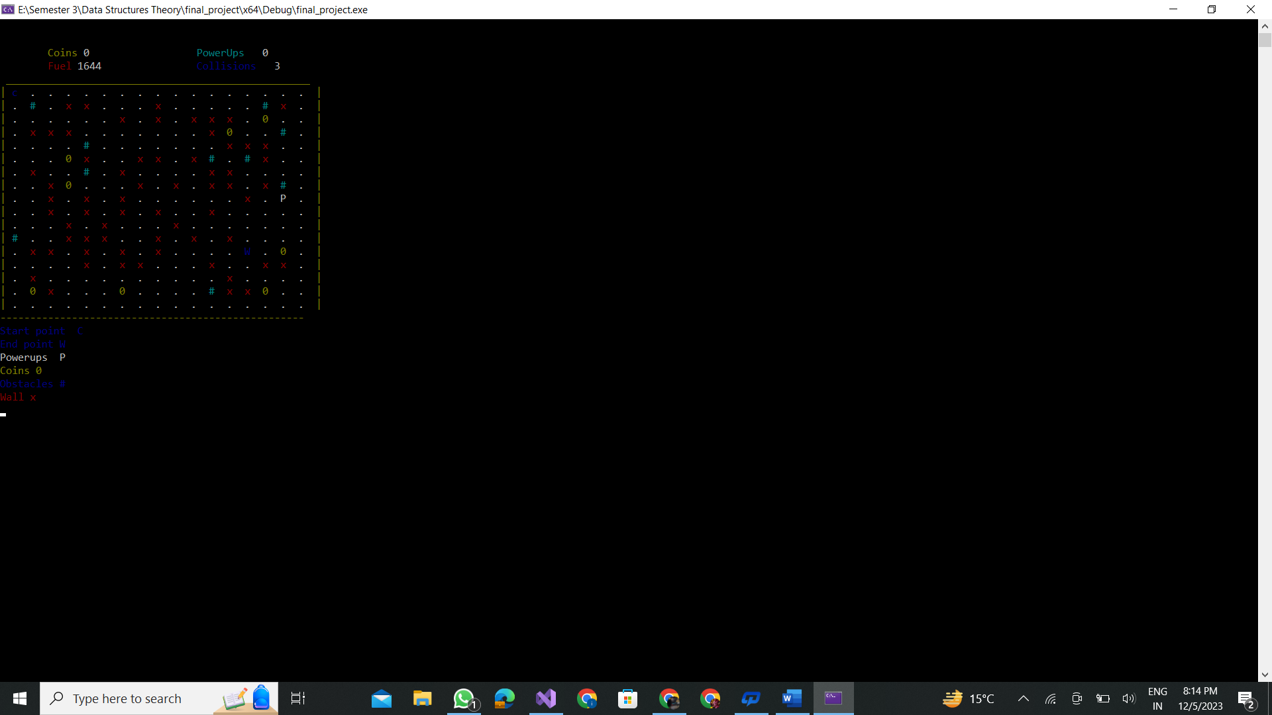

# Table OF Icons Used

|  |  |
| --- | --- |
| Power-Ups | P |
| Start Point | C |
| End Point | W |
| Coins | 0 |
| Obstacles | # |
| Walls | X |

## Automatic gameplay:

In automatic gameplay the user will enter the start point and end point from the grid then we will make the car move from the start point to the end point by taking the shortest path.



## Scoring system:

we have made a valid scoring system that will calculate the score based on how many times you hit the wall if you hit the wall 3 times game is over, if you hot the obstacle Fuel will be -50 and how many coins have collected it is multiplied by 10 and power-ups will double you Score and the longer you take the more chances are to minus your Score

Formula:

|  |
| --- |
| Score += Fuel;  Score += coins_Collected * 10;  Score += Collision * 20;  Score -= time sec;  Score = 000 |

## Leader board.

In leaderboard we are using binary search tree to maintain the score of the users and also add the name of user when the game start.

Leader Board will store the only High Score of the user and will delete the Pervious Old Score.

## Obstacles:

We have also introduced the obstacles that make the game more interactive and when the user hits the obstacles the user scores get decreased .

## Coins:

We have also introduced coins in our game that also make the game more attractive and when the user collects the coins the score increases at more rate.

## Powerups:

We also have introduced powerups in our app that will increase the score at higher rate .

# Objectives of the game:

The main objective of the game is that the user has to travel in the car from the start point to the end point and the user has to follow the game rules so that he will be able to achieve his goal.

# Controls of the game:

We have introduced a very simple control in our game. The user can go up and down in the menu by using the arrow up and arrow down key and he can select any option using enter and then he can control the car by using the arrow up ,down , left , right key.

# Data structures used:

## linked list:

We have used linked list in our game for the implementation of adjacency list and also, we have used it for the implementation of coins in our game.

## Queue:

We have used queues for the implementation of obstacles and do all of the obstacles related implementation using queues.

## Binary search tree:

We have used a binary search tree for the implementation of the leaderboard.

## 6.4 Graphs:

We have used the graph for making the grid that is displaying all the nodes and also, we have used this for traversing the car all our the grid.

# Main Game functions:

**QueueNode and Queue Classes:**

QueueNode represents a node in a queue with x and y coordinates.

Queue is a template class representing a queue of nodes with methods for push, pop, checking if empty, and displaying the queue.

**NodeBinary and BinaryTree Classes:**

NodeBinary represents a node in a binary tree with an integer data value and a string name.

BinaryTree is a binary search tree that can insert nodes and display them in an in-order traversal.

N**ode and linkedlistForGraph Classes:**

Node represents a node in the grid with information about its position, data, and connections.

linkedlistForGraph represents a linked list used to store connected nodes in the grid.

**GridGraph Class:**

GridGraph is the main class that manages the grid, connections, and gameplay.

It includes methods for creating a grid, connecting nodes, displaying the grid, generating random obstacles, coins, and power-ups, handling player movement, and managing the game state.

There are also methods for exporting and importing scores, setting start and winner nodes, and displaying the scoreboard.

**Gameplay and Score Handling:**

The GamePlay method handles the interactive gameplay, where the player can control movement.

The ScoreBoard method displays the score based on collected coins, power-ups, collisions, and steps taken.

**Automatic Gameplay:**

The automaticGameplay method simulates automatic gameplay from a specified start to end position.